CALENDAR 2024
Inter Expo Center
Guest events / Exhibitions
https://en.iec.bg/

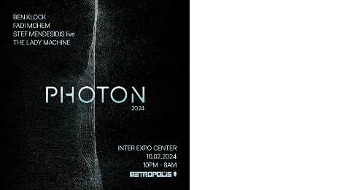
10.02 - 10.02.2024
PHOTON 2024
BEN KLOCK FADI MOHEM STEF MENDESIDIS (LIVE) THE LADY MACHINE
METROPOLIS and Jassen Petrov / Metropolis (Official)

13.02 - 16.02.2024
SIHRE
International exhibition for hotel, restaurant, catering and SPA equipment
Inter Expo Center

23.02 - 25.02.2024
4 Quadrant Quantum Thinking
This program will move you to the next stage of understanding the mind and experiencing the universe on new unexpected levels
Erickson Coaching International – Bulgaria

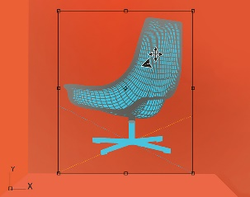
13.03 - 16.03.2024
EXPOMEBEL
International exhibition for furniture, interior design and home accessories
Inter Expo Center and Bulgarian Branch Chamber of Woodworking and Furniture Industry (BBCWFI)

13.03 - 15.03.2024
HOLIDAY & SPA EXPO
International tourist fair
Inter Expo Center

03.04 - 06.04.2024
ARCHITECTURAL BUILDING WEEK
International business exhibition for energy efficient, ecological and functional construction
Inter Expo Center

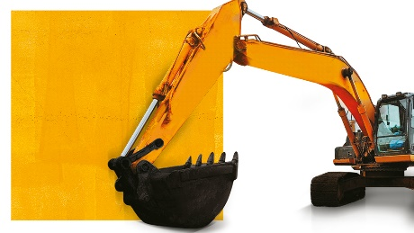
03.04 - 06.04.2024
ATEST EXPO
Large construction machinery and construction mechanization
ATEST

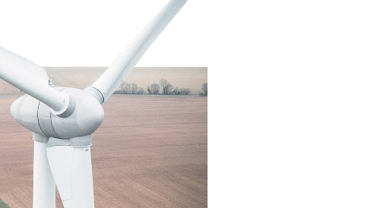
03.04 - 06.04.2024
GREEN ENERGY
Exhibition for energy efficiency and renewable energy, waste management and recycling, smart cities
Inter Expo Center

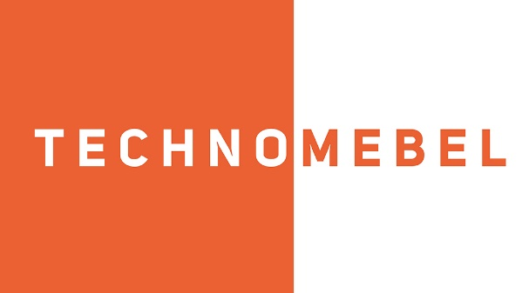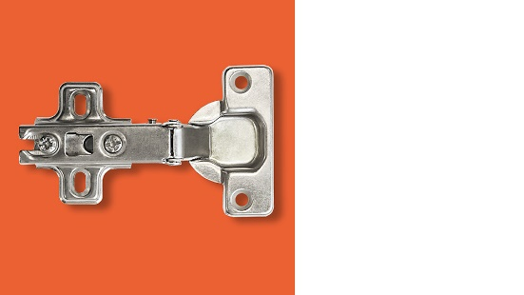
23.04 - 26.04.2024
TECHNOMEBEL
International exhibition for woodworking and furniture industry
Inter Expo Center and Bulgarian branch chamber of woodworking and furniture industry

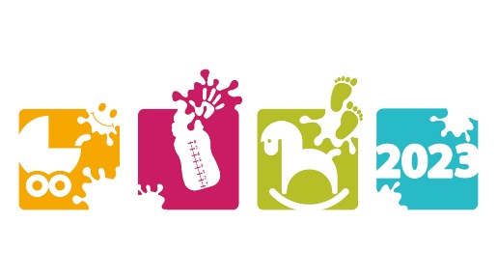
26.04 - 28.04.2024
BEBEMANIA
Exhibition of baby and children's goods and services
Association of child care providers in Bulgaria

29.05 - 31.05.2024
BULMEDICA
International exhibition for medicine
Inter Expo Center

29.05 - 31.05.2024
BULDENTAL
International exhibition for dental equipment, technics, materials, consumables
Inter Expo Center

29.05 - 31.05.2024
DERMA & AESTHETICS
International exhibition for dermatological and aesthetic medicine
Inter Expo Center

https://www.fair.bg/en/events

AGRA 2024
International Agricultural Exhibition 2024
from: 20 FEBRUARY 2024 to: 24 FEBRUARY 2024

FOODTECH 2024
International exhibition for food and drinks, packaging, machinery and technology
from: 20 FEBRUARY 2024 to: 24 FEBRUARY 2024

NATURE, HUNTING, FISHING 2024
International Exhibition
from: 03 APRIL 2024 to: 07 APRIL 2024

FLOWER SPRING 2024
Specialized exhibition of flowers, ornamental plants, garden equipment and supplies
from: 03 APRIL 2024 to: 07 APRIL 2024

HEMUS 2024
International Defence Equipment and Services Exhibition
from: 05 JUNE 2024 to: 08 JUNE 2024

